|  |  |
| --- | --- |
| Name: | Edward Eisenberger |
| ID# | 1066164 |
| Assignment 7 | |
| Date of Submission | July 8, 2019 |

Table of Contents

Overview 3

Part 1: Clustering Algorithms in AI Handout 3

Summary 3

Results 3

Part 2: N-D GMM Algorithm 9

Summary 9

Results 9

Part 3: Parallelization of KMeans++, KMedoids, and GMM Algorithms 11

Summary 11

Results 11

Part 4: N-D GMM Swarm Intelligence 12

Summary 12

Results 12

# Overview

Assignment 07 consisted of 4 parts implementing and Parallelizing KMeans, KMeans++, KMedoid, and the Gaussian Mixture Model (GMM) algorithms.

# Part 1: Clustering Algorithms in AI Handout

## Summary

Assignment 07 Part 1 consisted of implementing the examples in the ClusteringAlgorithmsInAI handout.

## Results

The results of the implementations are below.

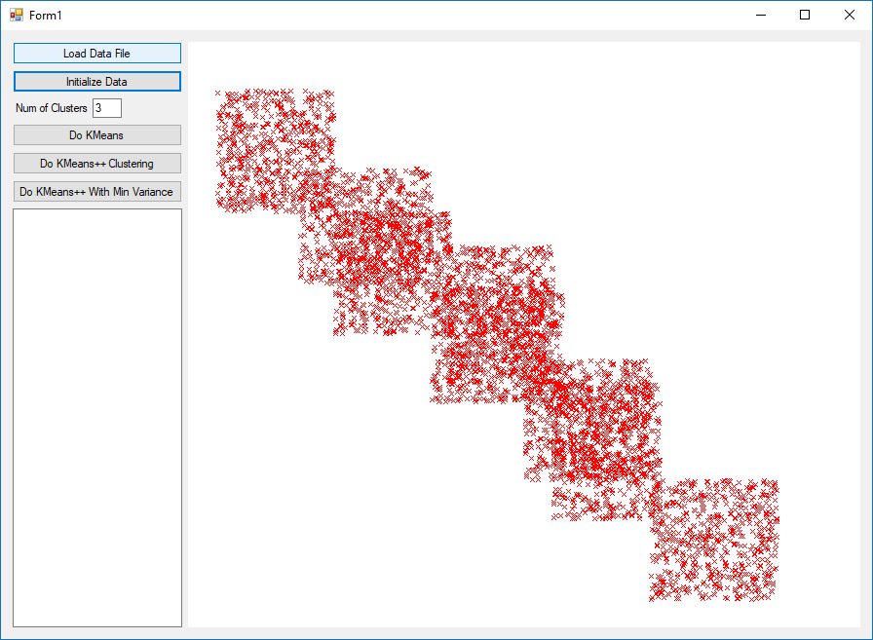

Figure - Initial Data

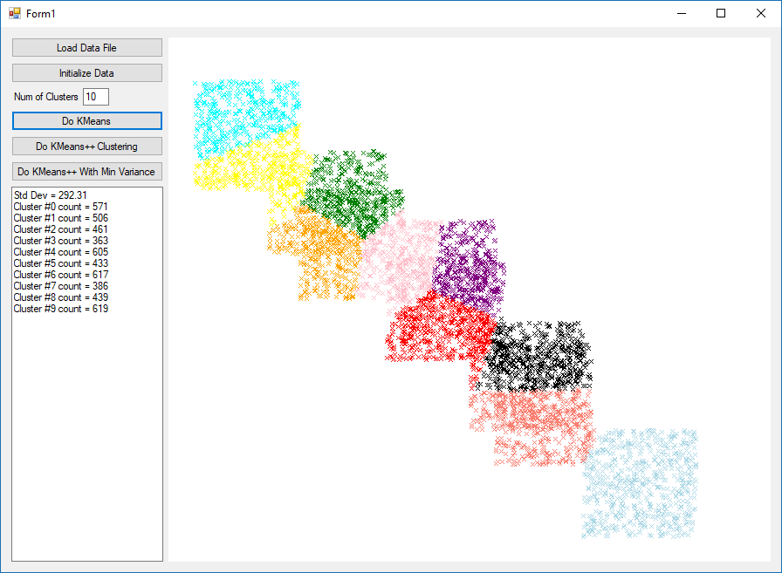

Figure - KMeans with K=10

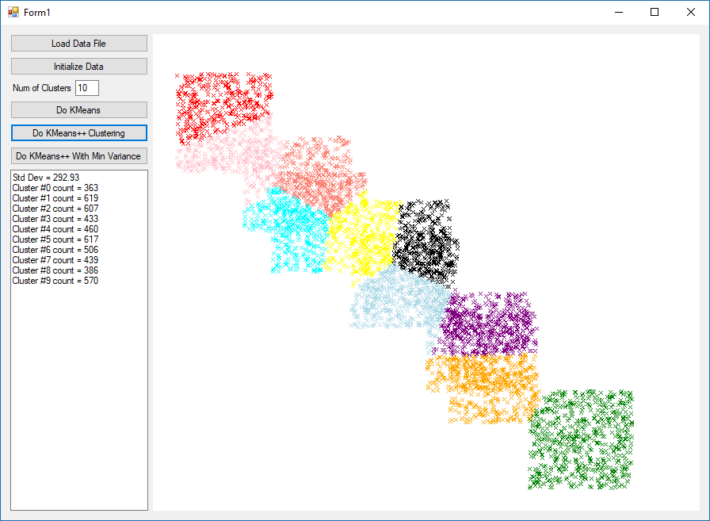

Figure - KMeans++ with K=10

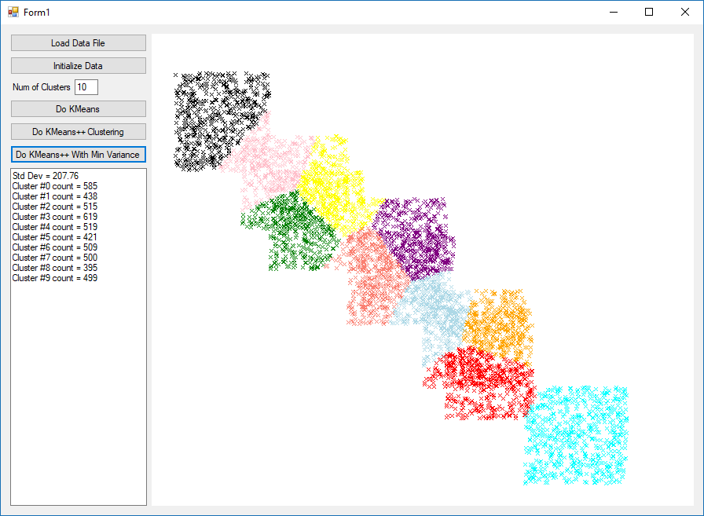

Figure - KMeans++ With Min Variance with K=10

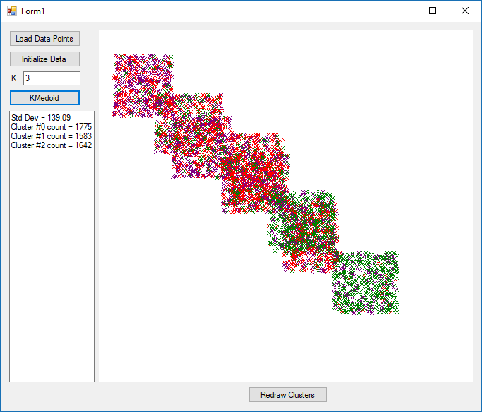

Figure - KMedoids K=3

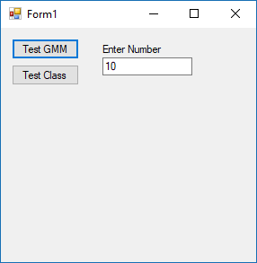

Figure - GMM Form

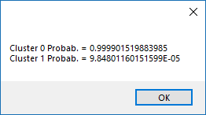

Figure - GMM Result

# Part 2: N-D GMM Algorithm

## Summary

Assignment 07 Part 2 consisted of implementing the N-D version of the GMM algorithm. A Windows Form was created which allows the user to browse for an image, specific the number of clusters (k), and perform the N-D GMM algorithm. A list box is populated with the resulting cluster identifiers. Selecting a cluster identifier displays only pixels belonging to that cluster. Also, the user is able to select the “Show Tennis Ball” button, which will display only pixels belonging to the cluster containing the majority of the tennis ball pixels.

## Results

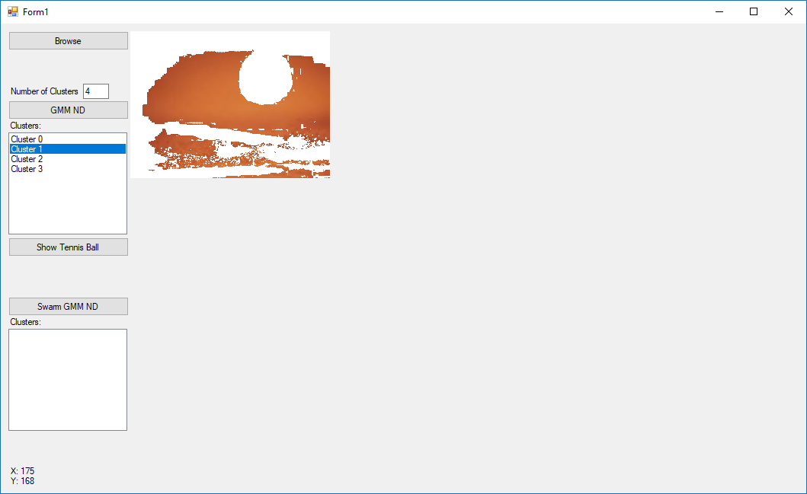

Figure - GMM With K=4 and Cluster 1 Selected

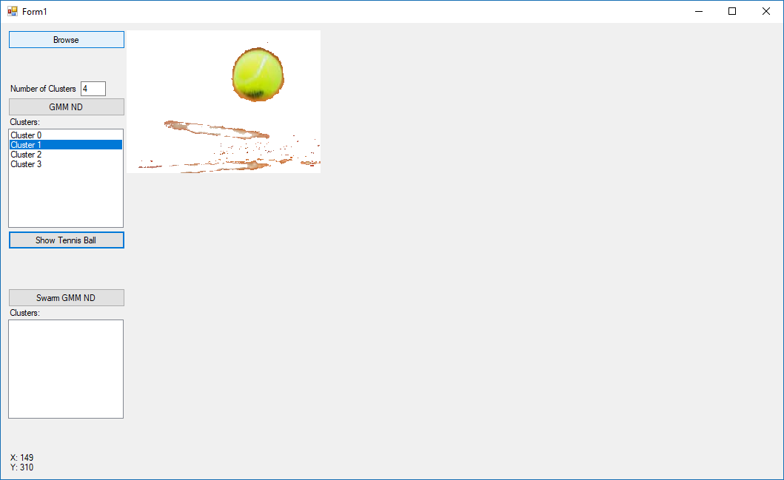

Figure - GMM With K=4 and Tennis Ball Cluster Selected

# Part 3: Parallelization of KMeans++, KMedoids, and GMM Algorithms

## Summary

Assignment 07 Part 3 consisted of modifying the KMeans++, KMedoids, and GMM Algorithms to utilize the Task Parallel Library and improve the processing time.

## Results

The results of each algorithm were the same as Part 1 and Part 2. However, the processing time required by the parallel implementation was roughly ¼ of the processing time required by the sequential implementation when run on a quad core CPU.

# Part 4: N-D GMM Swarm Intelligence

## Summary

Assignment 07 Part 4 consisted of implementing the 3-D GMM algorithm using Swarm Intelligence. Part 2 was modified to include a “Swarm GMM ND” button which launched 4 separate GMM algorithms in parallel, where each GMM assumed either 2, 3, 4, or 5 Gaussian distributions.

The results of all tasks were consolidated, sorted by Inertia, and added to a List Box where each GMM is depicted as their Gaussian Distributions (K=). Selecting a GMM from the list populates the upper list box with the clusters from the selected GMM.

Also, clicking any pixel within the picture will show only the cluster that the clicked pixel belongs to.

## Results

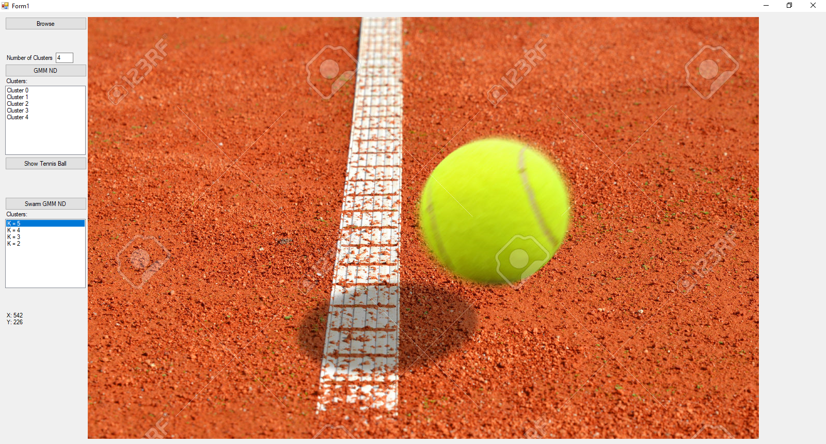

Figure - Full Image

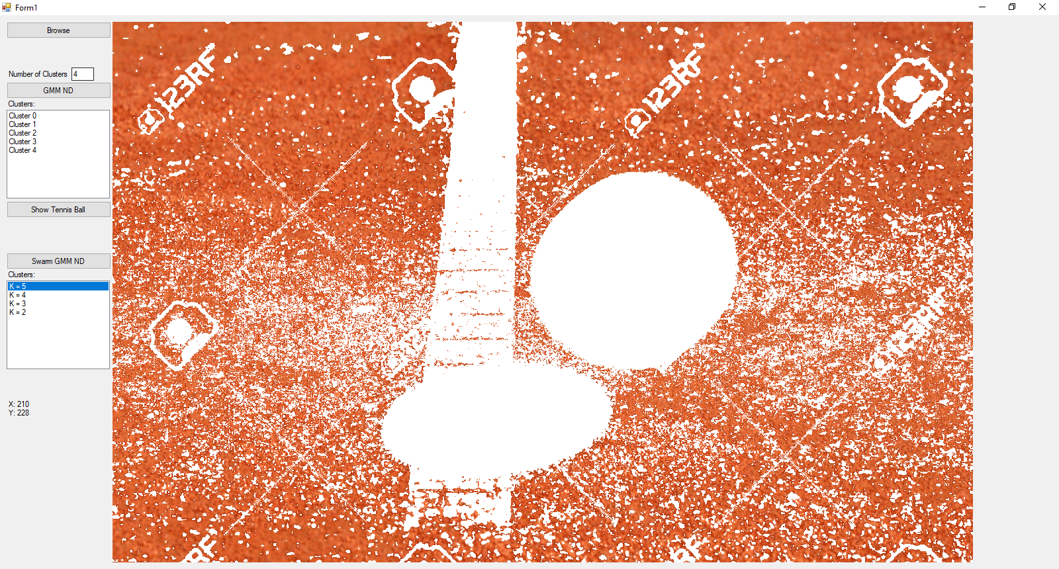

Figure - Pixel Clicked K=5

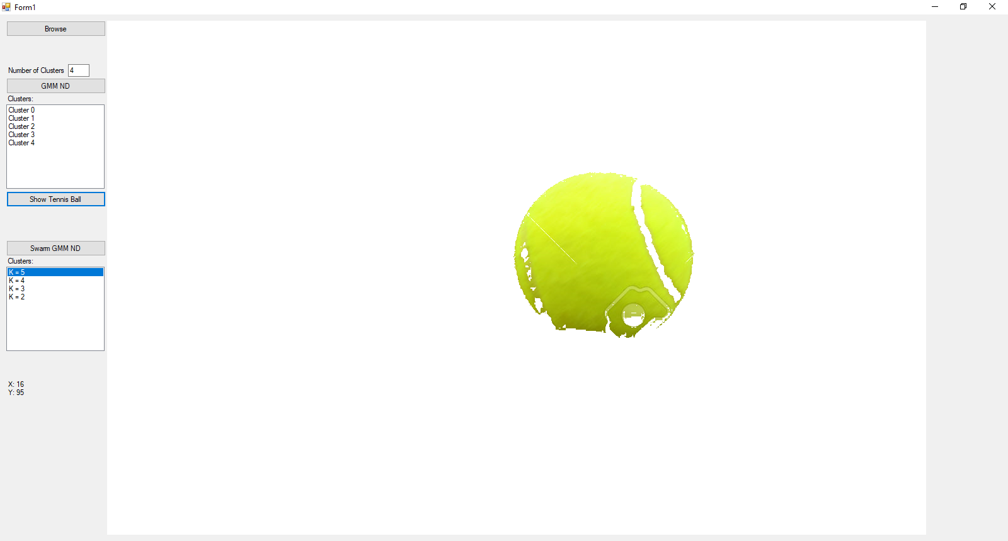

Figure - Tennis Ball K=5

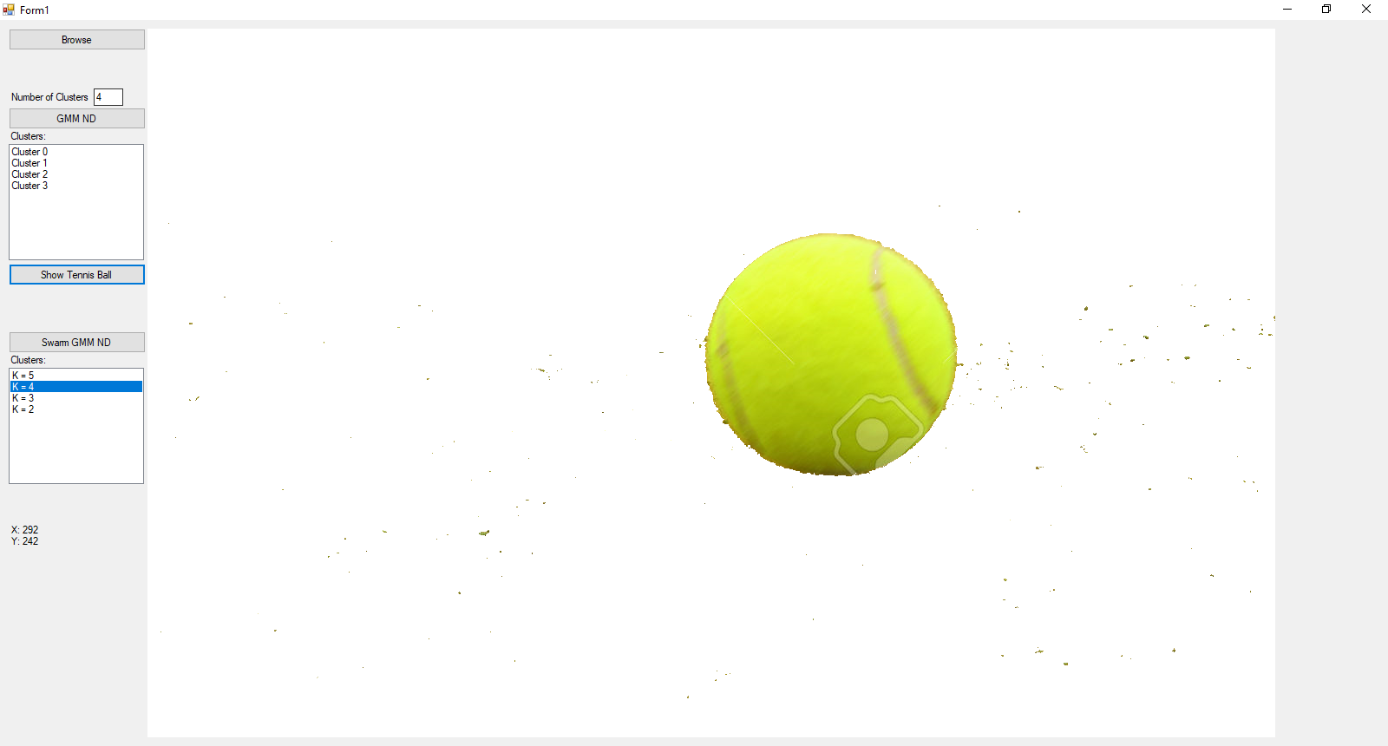

Figure - Tennis Ball K=4

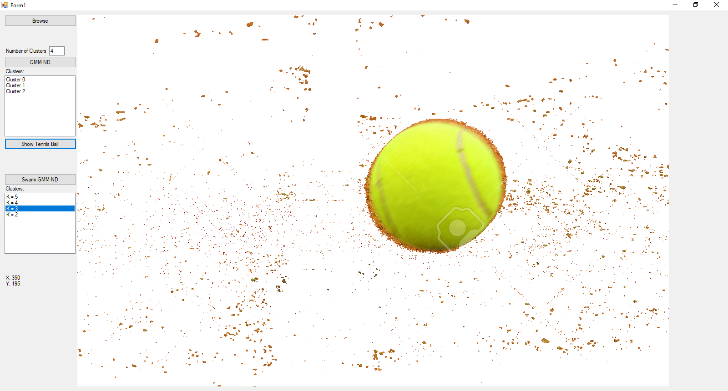

Figure - Tennis Ball K=3

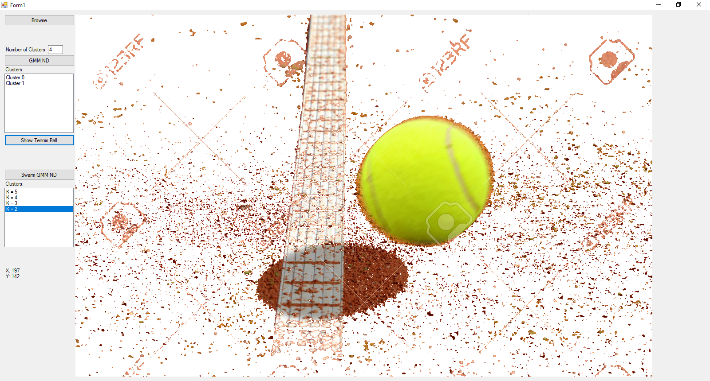

Figure - Tennis Ball K=2